
LAPORAN PRAKTIKUM

- Identitas Praktikum
Nama MK : Praktikum Pemrograman Berorientasi Objek
Kode MK : CAK2KAB4
Bobot SKS : 1 SKS
Tempat : Lab MM
Hari, tanggal : 6-03-2026
Jam : 13:00 - selesai
Topik praktikum : Modul-2
- Identitas Mahasiswa
Nama lengkap : Kafin Fazlur Rahman
NIM : 103112430097
Program Studi : S-1 Teknik Informatika
- Algoritma / studi kasus (jika ada) & Penjelasan
- Kode Program & Penjelasan
- Hasil Running Program

Code
import java.util.Scanner;

public class Main {
public static void main(String[] args) {

Scanner input = new Scanner(System.in);

System.out.print("Masukkan jumlah deret Fibonacci: ");
int n = input.nextInt();

if (n <= 0) {
System.out.println("Input tidak valid. Jumlah harus lebih dari 0.");
return;
}

int a = 0;
int b = 1;
int total = 0;
int max = 0;
int min = 0;
int genap = 0;
int ganjil = 0;

System.out.println("Deret Fibonacci:");

for (int i = 1; i <= n; i++) {
System.out.print(a + " ");

total += a;

if (i == 1) {
max = a;
min = a;
} else {
if (a > max) {
max = a;
}
if (a < min) {
min = a;
}
}

if (a % 2 == 0) {
genap++;
} else {
ganjil++;
}

int next = a + b;
a = b;
b = next;
}

double rata = (double) total / n;

System.out.println();
System.out.println("Total deret: " + total);
System.out.println("Rata-rata: " + rata);
System.out.println("Nilai terbesar: " + max);
System.out.println("Nilai terkecil: " + min);
System.out.println("Jumlah bilangan genap: " + genap);
System.out.println("Jumlah bilangan ganjil: " + ganjil);
}
}

Output:
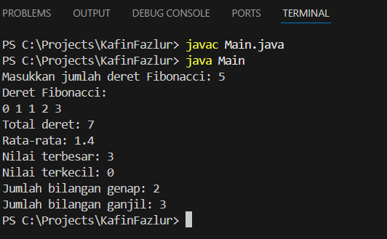

Flowchart:
